assignment #02

Course: CHE 341: Chemical Process Control
Term: Spring 2026
Professor: Dr. Michael Caracotsios
Office: EIB 244

Cell Phone: (630) 696-0934
E-mail: mcaracot@uic.edu

Name: _________________________________
Due Date: Friday, February 20th TA’s Mailbox

INSTRUCTIONS FOR ASSIGNMENT DELIVERY

- Prepare a typed report of your assignment.
- Include this cover page with your name in the report.
- Upload your report as a PDF file by the Due Date and Time(6:00PM) on the UIC Blackboard.
- Place a hard copy of your report as a PDF file by the Due Date and Time(Closing of the Business Day) in the TA’s mailbox.

- Assignments that are not typed will not be accepted.
- Late Assignments will not be accepted without prior approval.
- You may use the Internet as well as ChatGPT or other public tools as long as you place a written statement about their use in your assignment report

Problem A: Plant Wide Process Control.

A process flowsheet diagram for the production of iso-butane via the isomerization of n-butane is shown in the Figure below: The isomerization reaction takes place in the fixed bed reactor with pressure drop equal to 15 psi. The kinetics of the reaction are shown below:

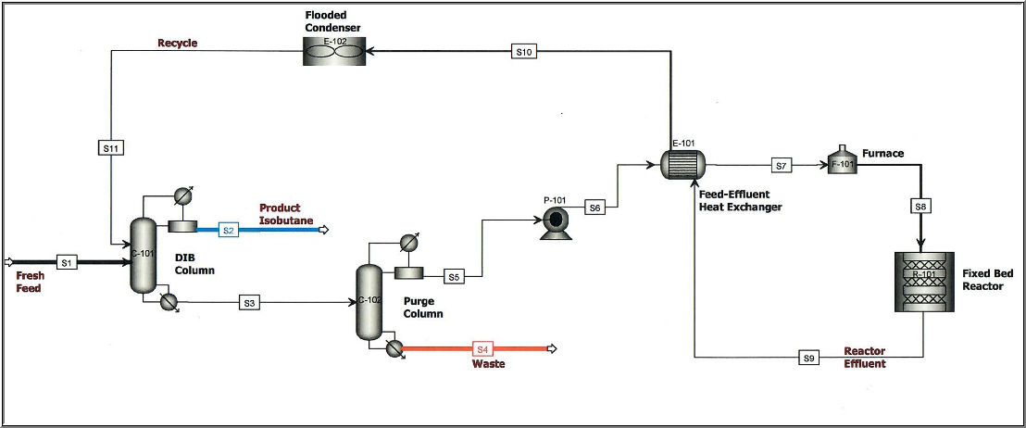

To better understand the process, open the attached ASPEN simulation and carefully study the operating conditions of all unit operations. The distillate product from the DeIsoButanizer column (DIB) has a specification of 2 mol% n-butane and is directed to a storage tank. The plant uses cooling water from near-by cooling tower designed with 75% efficiency with hot water inlet temperature of 120 ºF and air ambient temperature of 90 ºF with relative humidity 70%. A steam plant from a nearby facility supplies saturated steam (with quality 0.95) at three different levels of pressure: low pressure at 50 psig, medium pressure at 150 psig and high pressure at 600 psig. Natural gas from an existing pipe line is used for the fired heater that heats the feed to the reactor. The heat transfer coefficients in all the heat exchangers can be taken as the middle values of the ranges that are listed in the CHE Calculator.

Assume that the pressure drop in the heat exchanger is 10 psi both on the tube side and 5 psi on the shell side and the pressure drop in the fired heater is 60 psi. The pressure drop in the liquid line from the pump discharge to the inlet of the fired heater is approximately 8 psi.

This assignment has three parts:

Part A: Flowsheet Modifications

- First you must modify the simulation to obtain the product specifications and the diameters of the distillation columns. That will help you calculate the height of the liquid in the column sump. Some modifications will also be need to accommodate the additional information on pressure drop given in the problem description above.

- Second you must create three utilities (cooling water, steam and natural gas) and attach them to the appropriate unit operations. Utility consumption will be used to calculate the steady-state values of the manipulated variables for the process control loops that you will identify in Part B.

Part B: Identification and Design of Process Control Loops

Following the procedure that I have outlined in the lectures, calculate the Control Degrees of Freedom for this process and design all process control loops using the additional information outlined below.

Data and Assumptions

- Both refluxes in the DIB column and the Purge column are on flow control
- Residence time in the reflux accumulation drums: 4 min
- Residence time in the distillation column sumps: 2 min
- The waste stream is also on flow control due to environmental restrictions
- Neither the fresh feed nor the product flow rates are fixed by other plant considerations
- Heating value of natural gas used in the fired heater: 50.0 MJ/kg
- The heat capacity of water can be taken equal to 4.18 kJ/(kg C)
- Temperature rise in the cooling water is limited to 11 ºC

Process Variables Units for Reporting

- Liquid flow rates must be given in gpm
- Gas flow rates in lb/hr
- Temperature in deg F
- Pressure in psia
- Height in ft

For each control loop you have identified write a summary similar to the template shown below:

Template: Design of Process Control Loops

Loop # | Controller Description | Controlled Variable: CV | Set Point Value: SP | Manipulated Variable: MV | Steady-State Normal Value:
1 | DIB Column Reflux Flow | Reflux Flow |  | Reflux Flow
2
…
Part C: Process Simulation Calculations

From pilot plant studies it was recommended to increase the reactor feed temperature by 10 ºF in order to increase production rate. Change the set point of the temperature controller and answer the following questions after carrying out the simulation with the new reactor feed temperature.

- Briefly explain your logic in setting up the simulation for the change in the temperature loop set point value from 390 deg F to 400 deg F. Did you have to change the set points of any other controllers? If yes provide a brief explanation as to why and then enter their new values in the template shown below.
- Run the simulation in order to calculate the new steady-state values of the manipulated values for all controllers and enter the new values in the template shown below

Template: Simulation Calculations after Set Point Change

Loop # | Controller Description | Controlled Variable: CV | Old Set Point: SP | New Set Point: SP | MV | Old Steady State Value | New Steady State Value
1 | DIB Column Reflux Flow | Reflux Flow Rate |  |  | Reflux Flow Rate
2
…

